Table of Contents

Driver UI: 2

1.Driver Dashboard; 2

2.Package Scan TAB 3

Dumper UI 4

1.Trip Scan & Pick List TAB 4

2.Package Def & Handover TAB 5

# Driver UI:

## 1.Driver Dashboard;

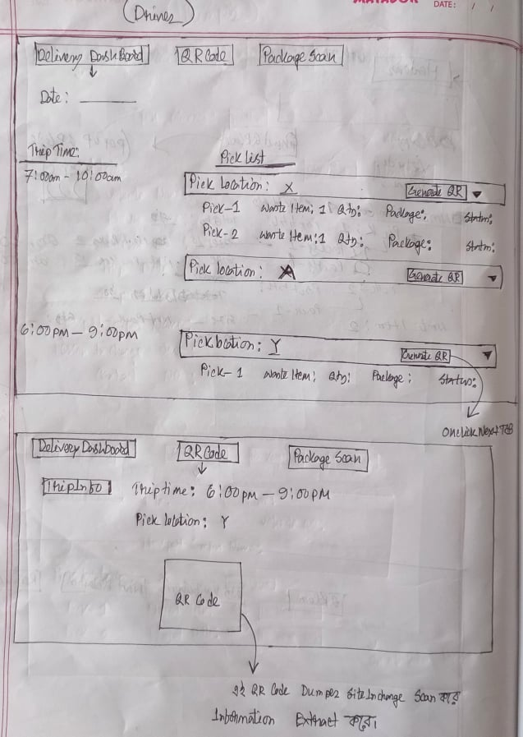

**Note: QR Code TAB not needed. It will show on POPUP**

## 2.Package Scan TAB

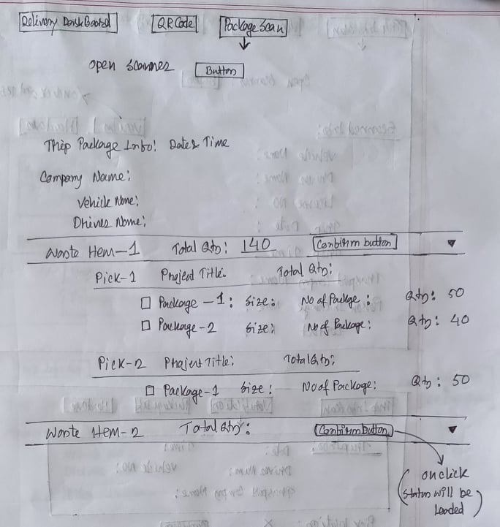

# Dumper UI

## 1.Trip Scan & Pick List TAB

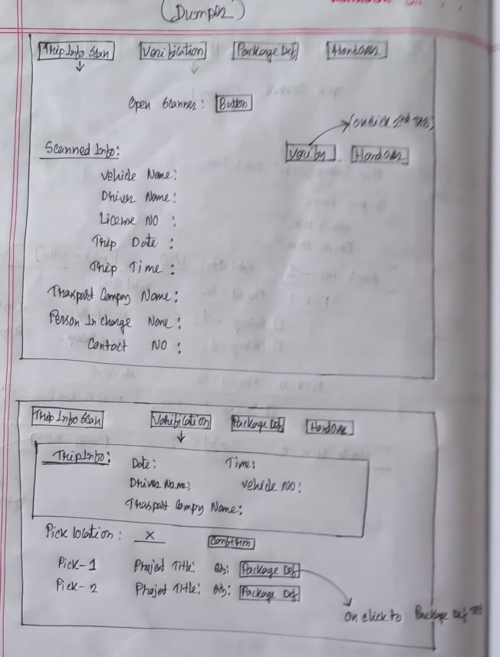

## 2.Package Def & Handover TAB

